WORKING CAT PERFECT MATCH FORM
Thank you for your interest in adopting a working cat. Our working cats are normally happier left to explore with limited human interaction, though some do become less wary of people once they become familiar with those taking care of them. They suit more rural locations with plenty of safe space to roam. We normally have a selection of working cats in at any one time which range from feral cats to street cats and inbetweeners.
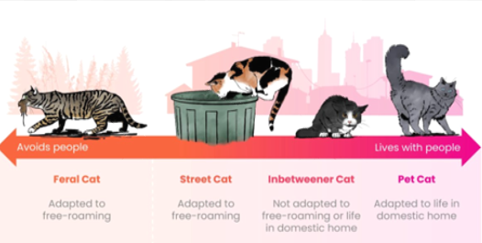
A FEW DETAILS ABOUT YOU
Mr/Mrs/Miss/Ms/other_______Surname _______________________
First name _______________ Email__________________________
Address_________________________________________________
_________________________ Postcode:______________________
Best telephone number(s) to contact on________________________
WHERE DID YOU HEAR ABOUT US?
☐​ Advertisement ☐​ Already aware of Mount Noddy ☐ ​ Website ☐​ Referred by other establishment ☐​ Just passing ☐​ Word of mouth ☐​ RSPCA enquiries ☐​ Other (please state) _________________________________________________
YOU ARE INTERESTED IN
☐​ Single cat ☐​ Pair of cats ☐​ Either ​
Age of cat ☐​ Less than 2 years ☐​ 2-5 years ☐​ 5-8 years ☐​ 8 years + ☐​ Any age
Gender of cat ☐​ Male ☐​ Female ☐​ Either
Have you seen a cat on our website that you are interested in? If so, please tell us their name______________________________________

A LITTLE BIT ABOUT YOUR HOME
Do you: ☐​ Own ☐​ Rent
If you rent, do you have written permission from your landlord? ☐ ​ Yes ☐​ No
Our working cats need a secure, enclosed sheltered area where they can be fed twice a day. They will also spend two weeks in the secure area before they can be released. Suitable areas must be dry, warm and give the cat privacy. Please tell us which type you are able to provide:
Stable ☐​
Large shed ☐​
Secure outbuilding ☐​
Other (please specify): ________________________________________________
A LITTLE BIT ABOUT YOUR FAMILY
Who lives at home? Adults________ Children________ Children ages___________
Do you own any dogs? ☐ Yes ☐​ No
If yes, have they lived with cats before? ​ ☐ Yes ​ ☐ No
Do you own any other pets? ​ ☐cats ​ ☐ rodents ☐ pet birds ​ ☐ other, please state ________________________________________________
WOULD YOU PREFER YOUR WORKING CAT TO BE
A feral cat unlikely to seek human interaction ☐​
An inbetweener adapted to a free roaming lifestyle who may seek human interaction ☐​
Either ☐​
Please email your completed form to jo.chambers@rspcasussexwest.org.uk
YOUR INFORMATION
The information you have provided on this form will be used by the RSPCA Sussex West Branch for the purposes of facilitating your application to adopt a pet. We will not use your personal information for any other purpose without prior notice to you and we will not share your personal information with third parties for their own marketing purposes.
We’d love to keep you updated about our fundraising activities, and ways in which you can support us to help animals. Please tell us how you would like to hear from us:
☐ email ☐ telephone ☐ text ☐ post
Should you wish to change your communication preferences at any time, please email info@rspcasussexwest.org.uk

